Experimental task n. 2
Pavel Ondračka
324363
28.05.2010

subject: Thermal electron emission

Introduction: Thermionic emission is the heat-induced flow of charge carriers from a surface or over a potential-energy barrier. This occurs because the thermal energy given to the carrier overcomes the forces restraining it.

task a) Measure the work function w of wolfram with Richardson-Dushman line
In any solid metal, there are one or two electrons per atom that are free to move from atom to atom. This is sometimes collectively referred to as a "sea of electrons". Their velocities follow a statistical distribution, rather than being uniform, and occasionally an electron will have enough velocity to exit the metal without being pulled back in. The minimum amount of energy needed for an electron to leave a surface is called the work function. The work function is characteristic of the material and for most metals is on the order of several electronvolts. Thermionic currents can be increased by decreasing the work function.

We determine temperature from Ohm's Law
ρ = resistivity = 4,89e-8 Ωm
α = součinitel odporu = 4,83e-3 K⁻¹
r = cathode radius = 5e-5 m d = cathode length = 1,5e-2 m
R = anode radius = 7e-4 m D = anode length = 10e-2 m
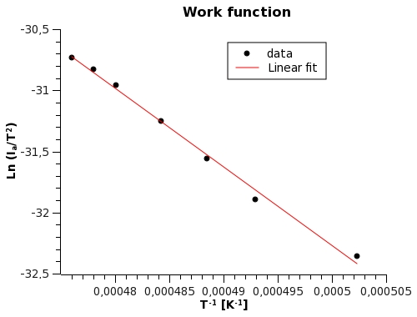
a (slope) = -60261 ± 2084
w = 5,19 ± 0,02 eV
table value w = 4,5 eV
task b) Calculate electric field intensity at cathode surface for used diode.

r = cathode radius = 5e-5 m
R = anode radius = 7e-4 m

E = 7578 U_{a}
for U_{a}= 150 V ; E = 1136 kVm₋₁

task c) Calculate electric field intensity at cathode surface for used diode.
Measure dependency I_{nas} = f (U_{a}) for U_{a} < 150V, and make graph with coordinates ln (I_{nas}) and sqrt(U_{a}).
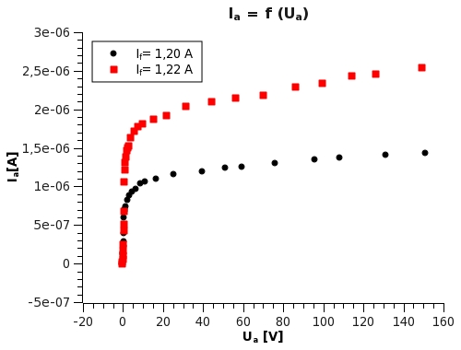
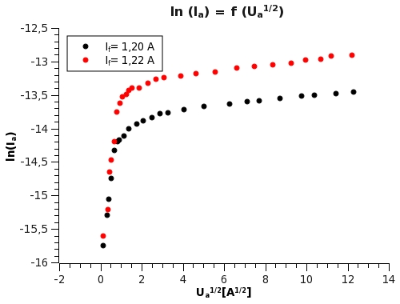
task b) For two values of heating current I_{f} measure inrush current and determine electron temperature
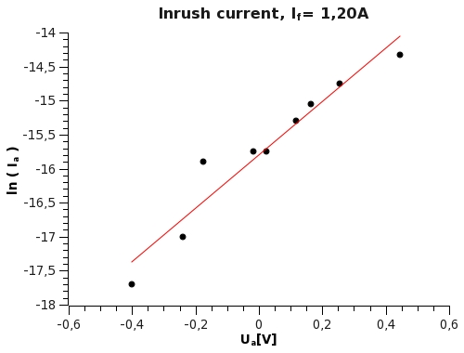
a (slope) = e/kT = 3,9 ± 0,4
T = 2970 ± 300 K

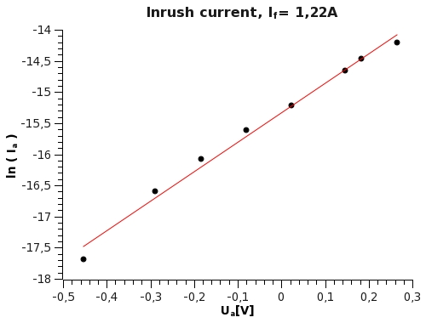
a (slope) = e/kT = 4,73 ± 0,19
T = 2450 ± 100 K

Conclusion: I was able to successfully determine wolfram work function, however my result is little bit higher than table value. I was also able to calculate electric field intensity at cathode surface and all plots have shape in accordance with instruction manual. Also electron temperatures ale in reasonable ranges.

